Credit Card Defaults Analysis

(Solution)

This project has an aim to build visualisation dashboards to get an insight into the data. Following dashboard contains various widgets giving an overview of measures in data.

The goal is to identify the impact of various factors such as age, marital status, education and gender on credit cards payment.

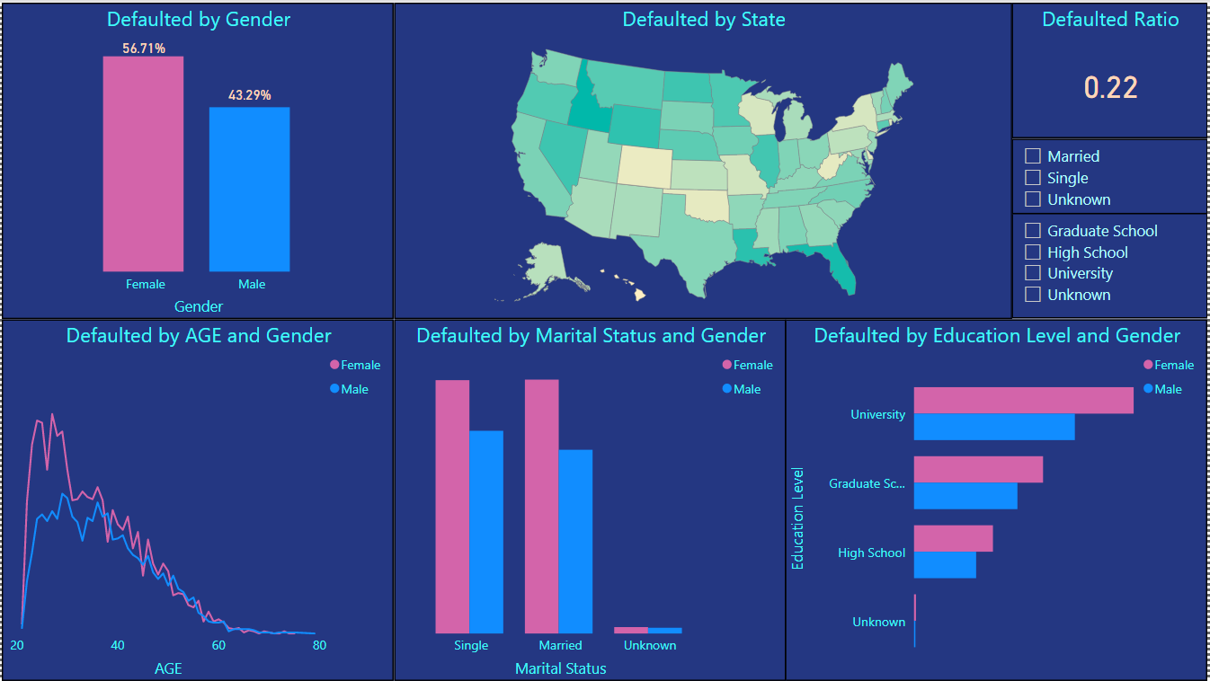

From the dashboard, we can establish the following inferences -

* As per the given data, it can be observed that more females are defaulting on their payments. Furthermore, taking age factor into account, women in the age group of 20 to 30 are more likely defaulting on their payment. Otherwise taking gender as the factor for comparison, men and women are equally responsible for the default.
* Marital status is not playing much of a role when it comes to default.
* Higher Education Level comes up with better job opportunities. High salaried employees do get benefits from banks concerning credit facilities resulting in more run out on credit payments.
* Apart from counts, ratio counts give a better insight into the data which are represented here in the form of cards. Slicers for education level and marital status help us understand individual values without breaking them into gender criteria.